**20200118 -Starter Book Assignment Report**

Building out the KickStarter Data map with color for the encountered States, PercentFunded, AverageDonation, Category and Sub-Category along with their Counts using Text Substringing and Length.

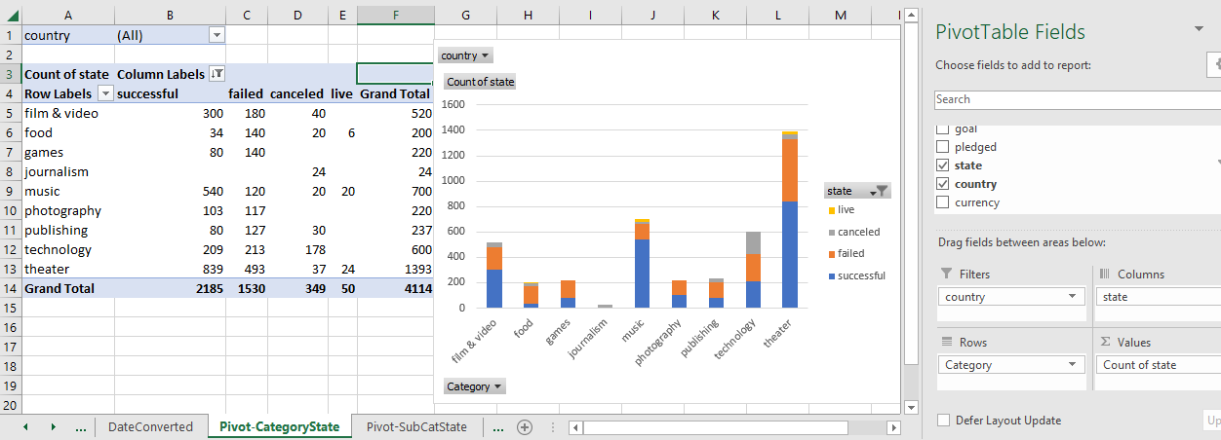

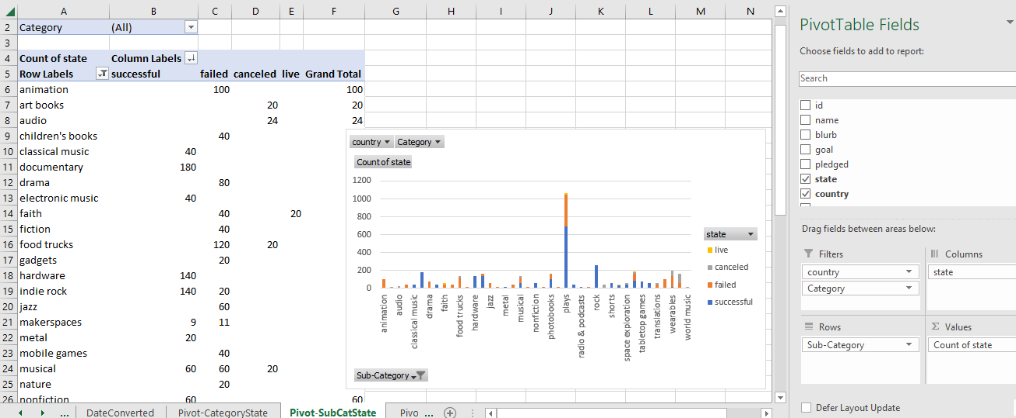

Additionally, the Deadline and Launched dates were translated to DateCreatedConversion and DateEndedConversion. These values were then plotted over time by month.

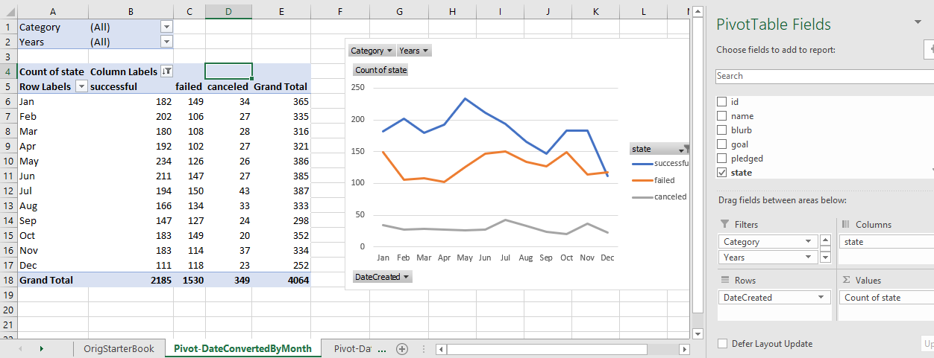

1. A. Although many different groups initiate Kickstarter projects, Plays far and away are the most used.
2. Although Theater as a category has the greatest nbr of projects, Plays specifically comprise the biggest part.
3. Likewise, although many Kickstarter projects fail or are canceled, far more succeed than fail.
4. As a percentage, very few Kickstarter projects end up being canceled within the scope of the data…
5. As to Limits, we only have data for 2009 – 2017. We also do not have within the tabular data details as to which Kickstarter funded projects ever went on to be produced.

Further examination of the raw data proposed a slightly different way to present the cumulative information. By examining the data previously presented by State by Month for each of the States, in a by State by Year for each of the States showed a very interesting bit of info…

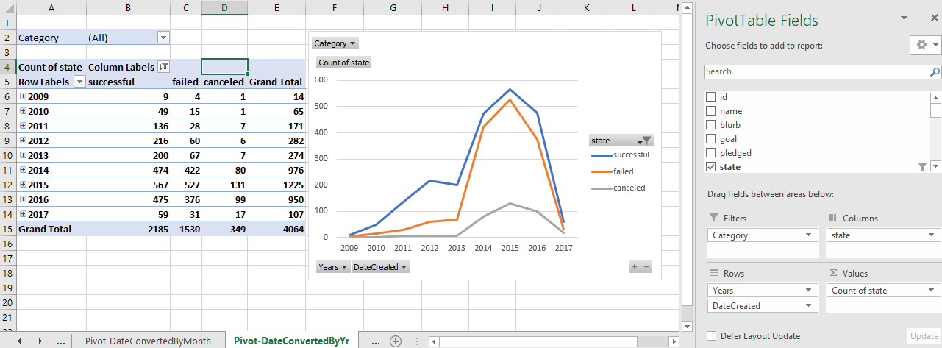

1. It is readily visible from this chart that the nbr of Kickstarter projects grew quite fast into 2015, and then dropped off dramatically to an all-time low in 2017.

Notably, Kickstarter started in 2009, and all internet crowd funders were included in a lawsuit in 2015. Additionally, in 2017, one of the original three members of the Kickstarter company left the company. Whether these events played a part in the dramatic falloff of Kickstarter projects or not can not be determined from the data provided, nor whether the entry of other crowd funding entities into the market contributed to this same falloff.

Further, looking at the data by country…

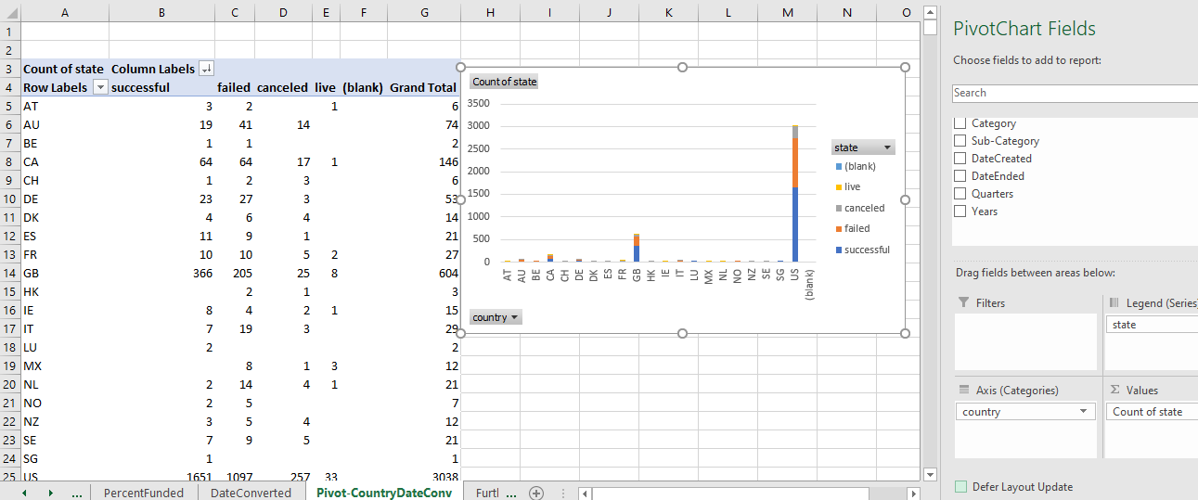

It is readily visible that the vast majority of Kickstarter projects are sourced from the US with England being the only other country close and its numbers are only 1/5th the US. However, it is of interest that in the US and GB, there are significantly greater numbers that succeed versus many other countries.

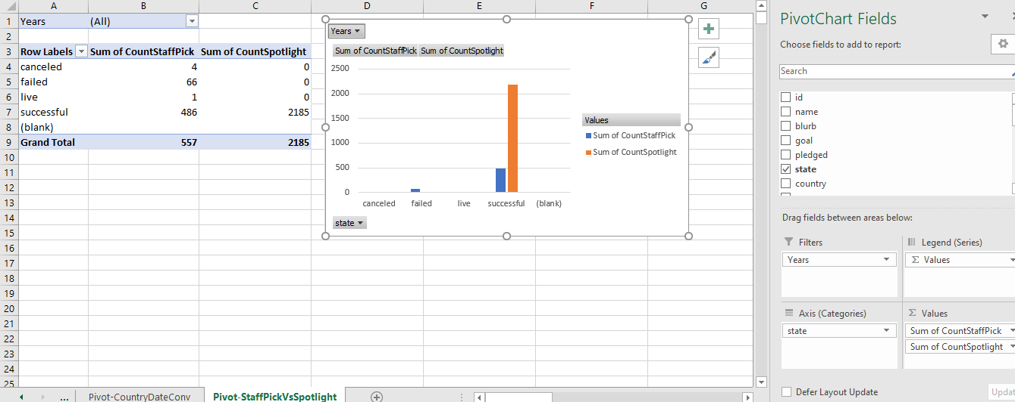

It is interesting that those Kickstarter Projects which have been “Spotlighted” are all successful, while some which were StaffPicks were successful and some were not.

**Bonus:**

**Outcomes Based On Goal**

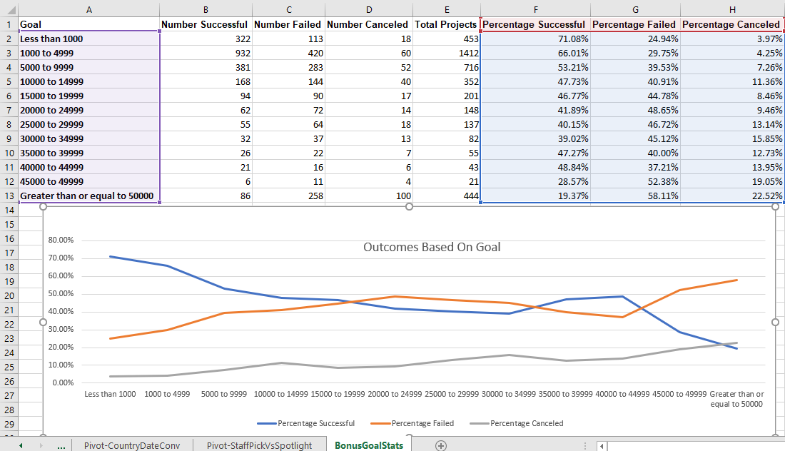

Looking at the chart above and the table that sourced it, it is apparent that there is a greater success rate for those Kickstarter Projects with lower $ goals (under $10,000). Why is not as clearly obvious.